# **Part 3 - Practical Steps for Implementing Canada's Innovation Strategy**

Building on our analysis of Canada's innovation standing in Part 1 and the strategies identified from top-performing countries in Part 2, we now present a comprehensive implementation plan to enhance Canada's innovation ecosystem. Our approach addresses key weaknesses while leveraging existing strengths, with clear timelines, budget allocations, and measurable outcomes.

**Strategic Implementation Framework**

Our implementation strategy unfolds across three distinct phases to ensure proper resource allocation and progress tracking. Phase 1 (2025-2027) focuses on addressing critical gaps and establishing foundational programs. Phase 2 (2027-2030) will scale successful initiatives and strengthen ecosystem connections. Phase 3 (2030-2035) aims to achieve long-term strategic goals and establish global leadership.

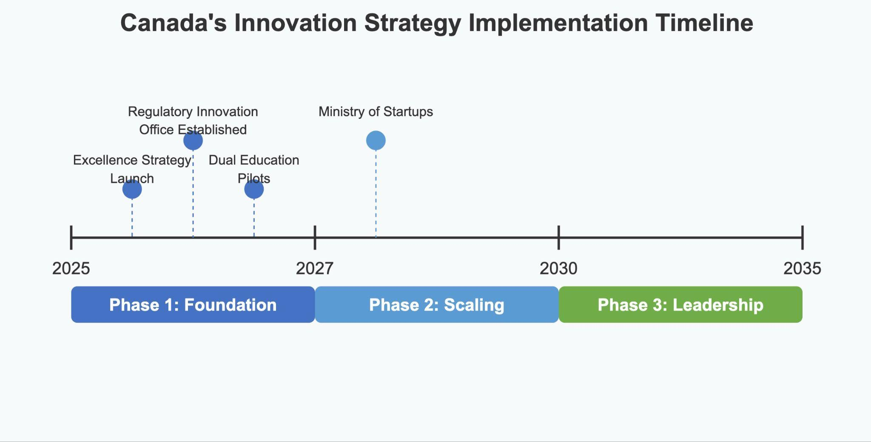

*Fig 1: Strategic implementation timeline showing key milestones across three phases*

## **1. Enhancing R&D Investment**

As identified in Part 1, Canada's R&D score of 0.6996 falls significantly below top-performing countries, requiring immediate intervention.

### **Implementation Steps:**

#### **A. Canadian Excellence Strategy (Modeled after Germany's Exzellenzstrategie)**

The Canadian Excellence Strategy will launch in Q3 2025 with full implementation by 2027. This program requires an initial allocation of $1.2 billion over 5 years, partially funded through reallocation from the existing NSERC budget ($1.3 billion annually) and supplemented by new appropriations. Success will be measured by increasing R&D spending from the current 1.7% of GDP to 2.5% by 2030, establishing 10 Excellence Clusters in strategic sectors by 2027, and generating 25% more high-impact research publications by 2028.

#### **B. Strategic Innovation Fund Expansion**

An immediate expansion of the Strategic Innovation Fund in 2025 will increase funding from $2.2 billion to $3.5 billion, sourced through public-private partnerships and innovation bonds. This initiative aims to stimulate a 30% increase in private sector R&D investment by 2028 and a 40% increase in patents filed by Canadian entities by 2029.

## **2. Workforce Development and Skills Alignment**

Addressing the workforce skills gap (score of 0.737) identified in Part 1 requires coordinated education and industry initiatives.

### **Implementation Steps:**

#### **A. Canadian Dual Education Program (Adapted from Germany's model)**

The Canadian Dual Education Program will pilot in 5 provinces by Q1 2026, with nationwide implementation by 2028. This initiative requires $800 million over 5 years, funded through provincial-federal cost sharing (60-40) and industry contributions. The program aims to enroll 50,000 students by 2028, achieve an 85% employment rate for graduates, and reduce skills mismatch by 25% in targeted sectors by 2029.

#### **B. COMEUP Canada (Inspired by South Korea's startup networking platform)**

COMEUP Canada will launch in Toronto in Q2 2025, expanding to 5 major cities by 2027. With a budget of $45 million over 3 years funded by Innovation, Science and Economic Development Canada with private sponsorships, this platform aims to attract over 10,000 participants annually by 2027, facilitate $500 million in venture capital deals, and create more than 5,000 new jobs in innovation sectors.

## **3. Regulatory Reform and Business Environment Enhancement**

To improve industry activity (score of 0.765) and economic freedom, regulatory barriers must be addressed through strategic interventions.

### **Implementation Steps:**

#### **A. Canadian Regulatory Innovation Office (Based on UK's RIO)**

The Canadian Regulatory Innovation Office will be established by Q4 2025 and become fully operational by Q2 2026. With a budget of $75 million over 3 years from the Treasury Board Secretariat, this office will work to reduce time-to-market for innovative products by 35% in regulated industries, cut regulatory compliance costs by 25% for startups and SMEs, and process innovation sandbox applications within 45 days.

#### **B. Digital Regulatory Transformation**

The Digital Regulatory Transformation initiative will begin platform development in 2025-2026, with phased rollout during 2026-2028. Funded by $150 million over 4 years from the digital government services budget, this program aims to digitalize 90% of business-facing regulatory processes by 2028 and reduce administrative burden by 40% for new businesses.

## **4. Commercialization and Global Expansion Support**

Canada will leverage its strengths in ICT (0.9) and access to finance (0.87) while addressing commercialization challenges through targeted programs.

### **Implementation Steps:**

#### **A. Ministry of Startups and SMEs (Inspired by Korea's MSS)**

The legislation for a dedicated Ministry of Startups and SMEs will be introduced in 2025, with the ministry becoming operational by Q3 2026. With a budget of $1.8 billion over 5 years (consolidating existing programs) reallocated from the Business Development Bank of Canada and other agencies, this ministry aims to increase Canada's unicorn count from 17 to 40 by 2030, double the success rate of early-stage startups by 2028, and increase SME contribution to GDP by 15% by 2030.

**B. Global Growth Voucher Program (Based on Korea's model)**

The Global Growth Voucher Program will launch in Q1 2026 with a budget of $300 million over 3 years from Export Development Canada and Global Affairs Canada. This program will support 2,000 high-potential SMEs in global expansion by 2028, increase export revenue by $5 billion annually by 2029, and establish Canadian innovation hubs in 5 strategic global markets by 2028.

## **Budget Allocation and Funding Strategies**

Our strategic budget allocation prioritizes highest-impact areas while maintaining fiscal responsibility, with a total proposed budget of $4.37 billion over 5 years. This funding approach balances the need for significant investment with prudent financial management through strategic reallocation of existing funds ($2.85 billion, 65%) and carefully targeted new appropriations ($1.52 billion, 35%).

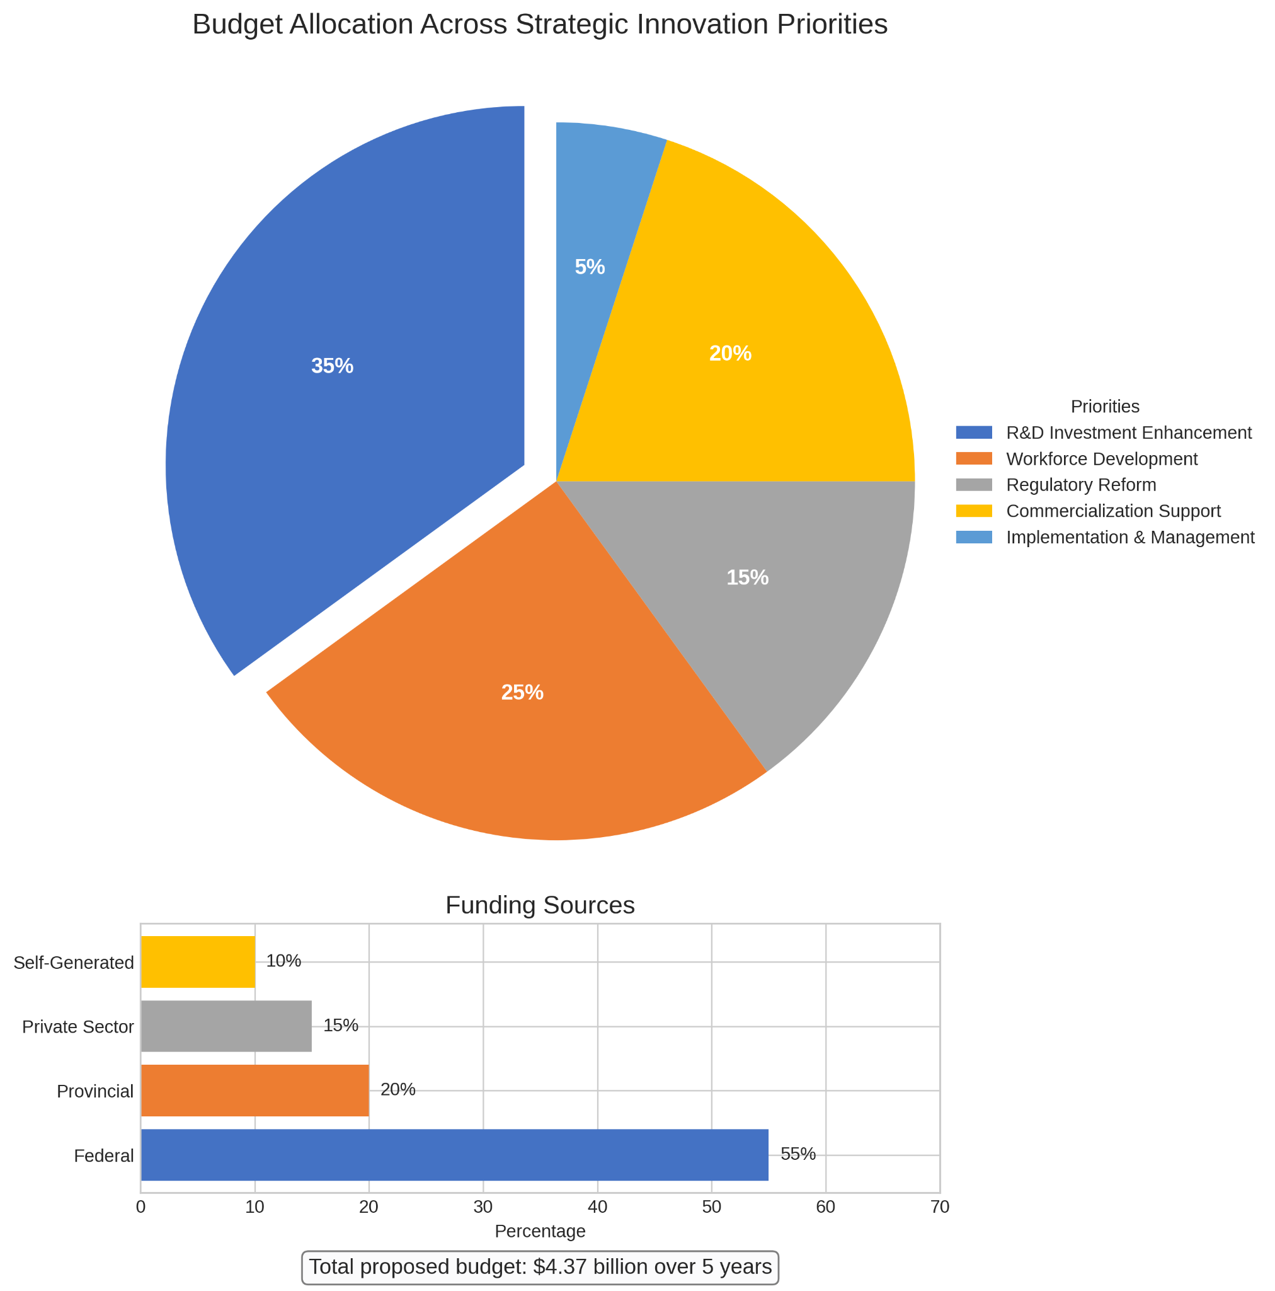

*Fig 2: Budget allocation across strategic innovation priorities*

The funding strategy diversifies financial responsibility across multiple stakeholders, with 55% coming from the federal government, 20% from provincial governments, 15% from private sector partnerships, and 10% from revenue generation from the programs themselves. This multi-source approach ensures sustainability and creates stakeholder commitment across the innovation ecosystem.

## **Expected Impact Analysis**

Based on our predictive models from Part 1 and benchmarks from countries analyzed in Part 2, we project substantial improvements across Canada's innovation landscape. Our implementation strategy aims to elevate Canada's Global Innovation Index ranking from 11th to the top 8 by 2030, while increasing R&D investment from 1.7% to 2.8% of GDP by 2032.

The economic impact extends beyond rankings, with the anticipated creation of more than 25 new unicorn companies by 2030 and a 30% increase in productivity across innovation-intensive sectors by 2029. These improvements will strengthen Canada's economic resilience, enhance global competitiveness, and create high-value employment opportunities across the country.

## **Risk Management and Mitigation Strategies**

Implementing such an ambitious strategy requires careful risk management. We've identified five key risks that could impact successful implementation and developed corresponding mitigation strategies for each.

Budget constraints present a high-probability, high-impact risk that will be addressed through phased implementation with clear ROI metrics to demonstrate value and secure continued funding. Policy inconsistency across election cycles poses another significant risk, requiring cross-party consensus building and establishment of long-term governance structures that can survive political transitions.

The talent shortage affecting innovation sectors will be mitigated through international talent attraction programs coupled with accelerated domestic skills development. Ensuring consistent private sector engagement will be achieved through co-creation approaches and transparent incentive structures that align business and national innovation goals. Finally, to prevent regional disparity in innovation benefits, we propose place-based innovation strategies with specific equity measures to ensure nationwide participation and benefit sharing.

## **Stakeholder Engagement and Governance**

The success of Canada's innovation strategy depends on coordinated governance and stakeholder alignment across multiple sectors. Our stakeholder engagement model establishes clear roles and accountability for each participant in the innovation ecosystem.

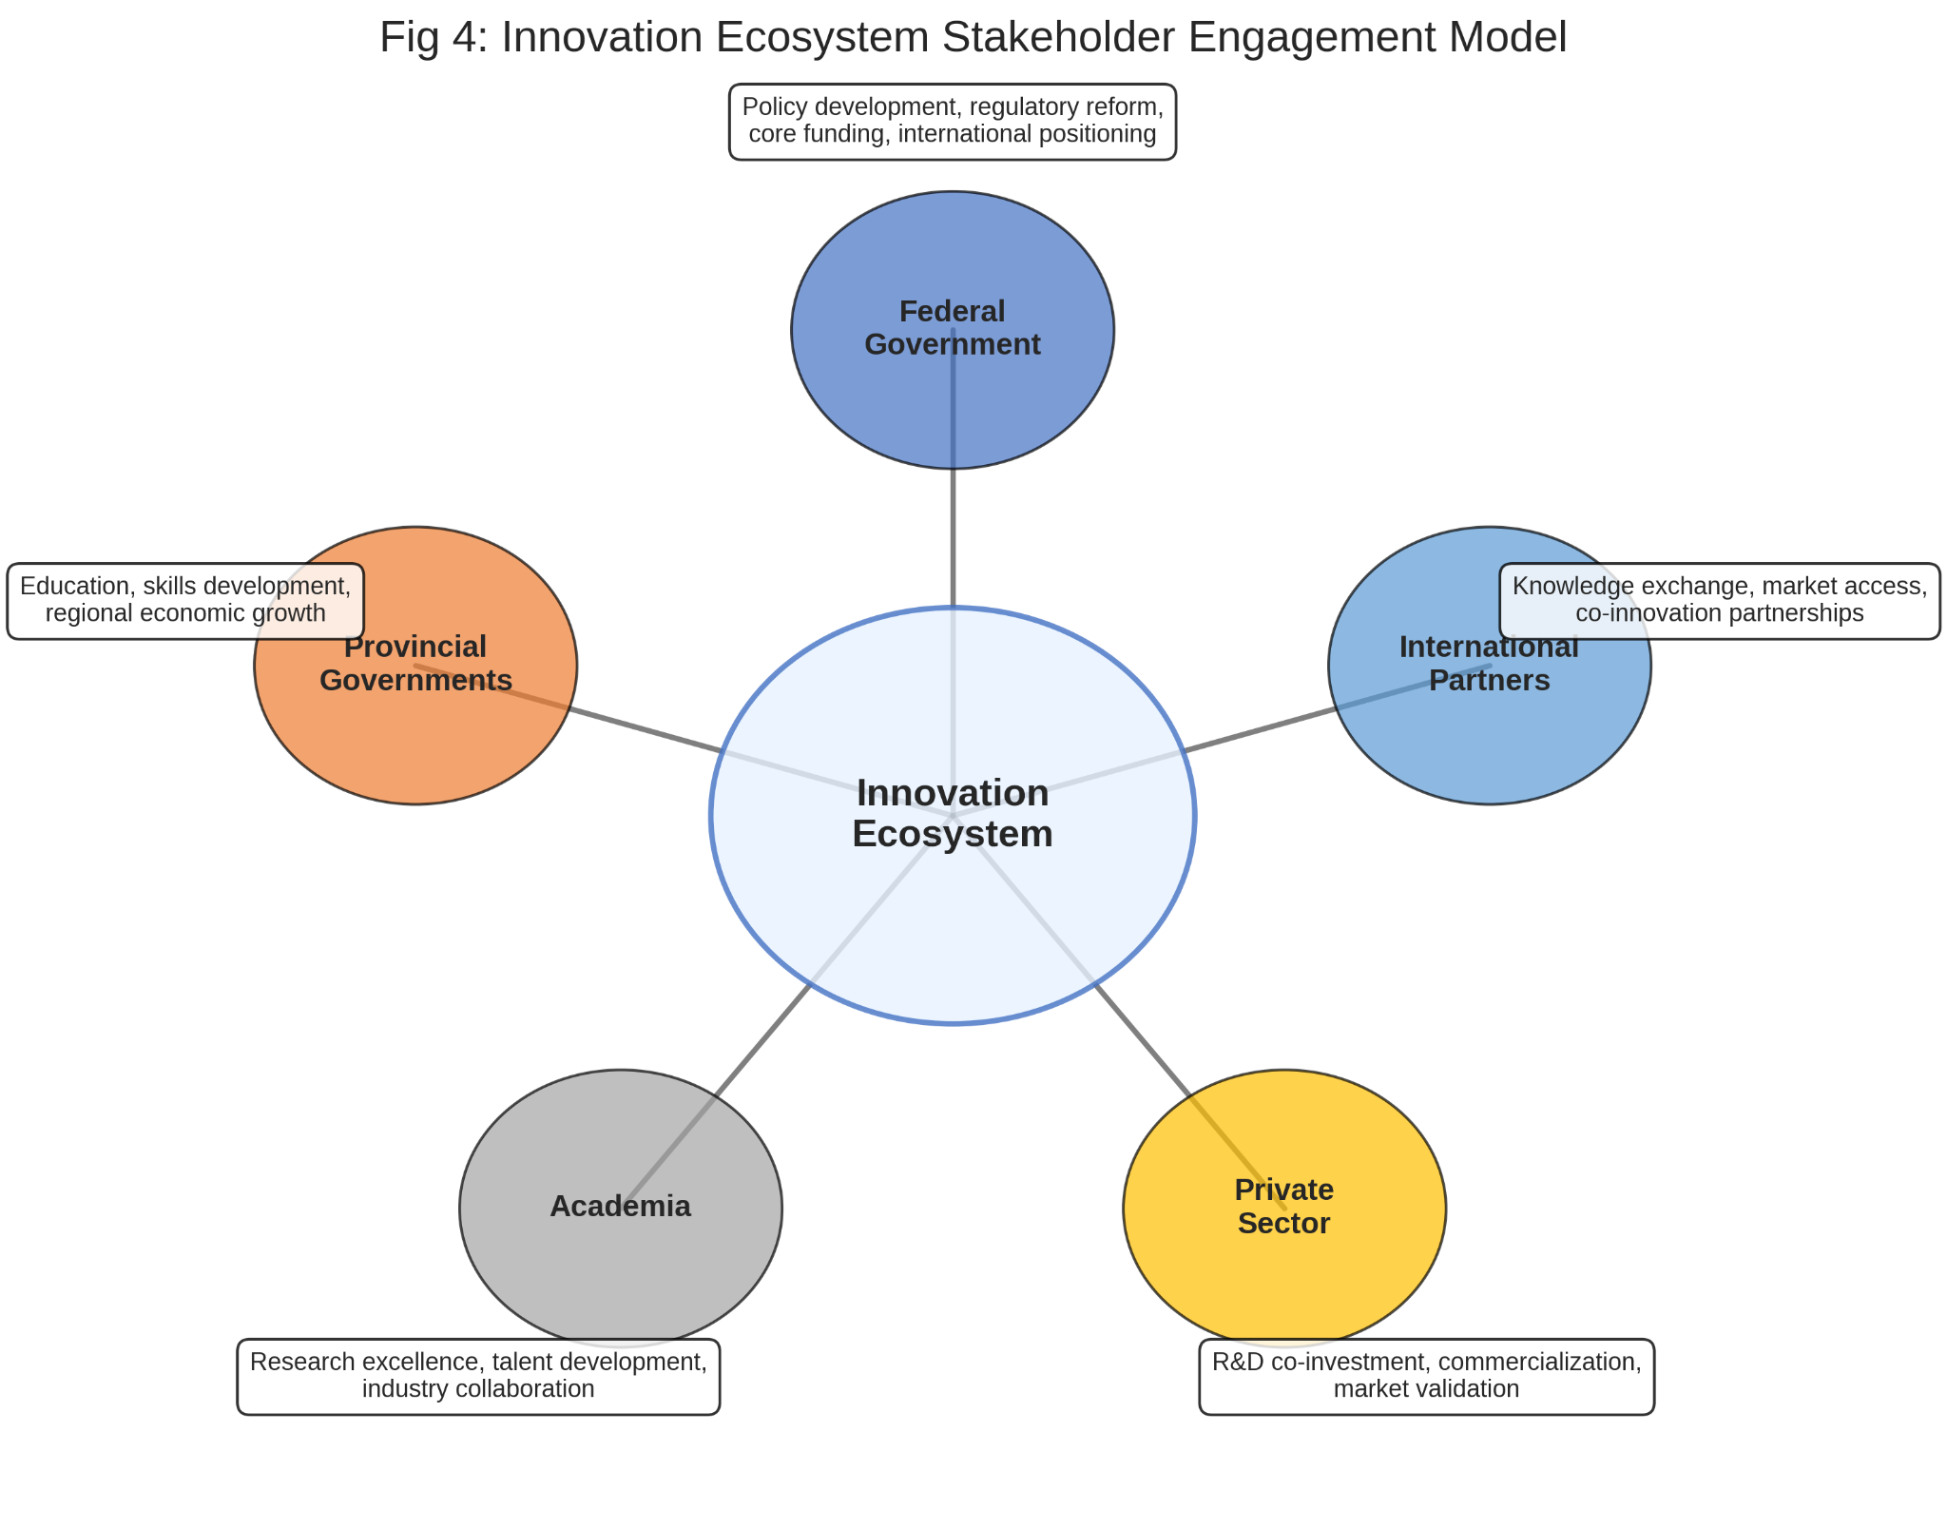

*Fig 3: Innovation ecosystem stakeholder engagement model*

The federal government will lead policy development, regulatory reform, and provide core funding while ensuring international positioning through strategic agreements. Provincial and territorial governments will focus on education, skills development, and regional economic growth while harmonizing regulations to reduce interprovincial barriers.

Academia will drive research excellence in priority areas, develop talent aligned with industry needs, and foster deeper industry-academic collaboration. The private sector's role encompasses co-investment in R&D, creating commercialization pathways, and providing market validation for innovations. International partners will contribute through knowledge exchange, market access opportunities, and co-innovation partnerships that connect Canadian innovation to global markets.

## **Implementation Roadmap (2025-2027)**

The first two years of implementation are critical for establishing momentum and demonstrating early wins. Our quarterly roadmap outlines the sequence of key actions to launch and operationalize each strategic initiative.

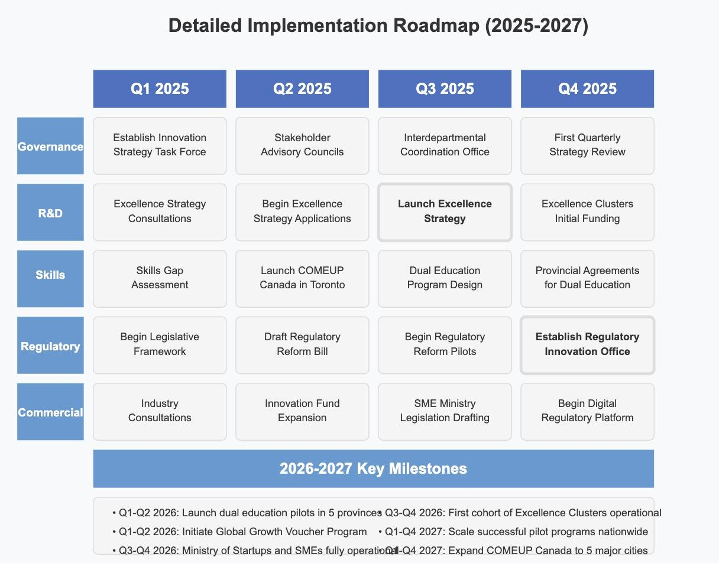

*Fig 4: Detailed implementation roadmap for first two years*

The implementation begins in Q1 2025 with the establishment of the Innovation Strategy Implementation Task Force, development of legislative frameworks for regulatory reforms, and launch of stakeholder consultations for the Excellence Strategy. By Q2 2025, COMEUP Canada will launch in Toronto alongside the Excellence Strategy application process and Strategic Innovation Fund expansion.

The Canadian Excellence Strategy officially launches in Q3 2025, accompanied by regulatory reform pilot projects and the design phase of the dual education program. Q4 2025 sees the establishment of the Regulatory Innovation Office, completion of initial funding for Excellence Clusters, and the beginning of digital regulatory transformation efforts.

During 2026, dual education pilots will launch in 5 provinces, followed by the Global Growth Voucher Program and the establishment of the Ministry of Startups and SMEs. By the end of 2026, the first cohort of Excellence Clusters will be operational, and initial program evaluations will begin. The year 2027 focuses on scaling successful pilots nationwide, expanding COMEUP Canada to 5 major cities, and transitioning to Phase 2 implementation based on impact assessments.

## **Conclusion**

This implementation plan provides a comprehensive roadmap to address Canada's innovation challenges identified in Parts 1 and 2. By focusing on R&D investment, workforce development, regulatory reform, and commercialization support, Canada can significantly enhance its innovation ecosystem. The proposed initiatives are based on successful models from top-performing countries, adapted to the Canadian context, with clear metrics for success and accountability mechanisms. Through disciplined execution of this plan, Canada can establish itself as "the country of innovations" and secure long-term economic prosperity and global competitiveness.